National Cancer Institute (NCI)

Division of Cancer Prevention (DCP) –

US-Latin American-Caribbean HIV/HPV Cancer Prevention Clinical Trials Network (ULACNet)

Minimum Data Set

Instructions and Guidelines

Version Control

Date | Author(s) | Version and Changes
1/27/2021 | DCP and IMS | 1.0
4/27/2022 | DCP | 2.0  Clarification of data elements for screening studies, minor edits

Questions and Comments
If you have any questions or comments regarding the Minimum Data Set (MDS) or the process for submitting your MDS submission to the Division of Cancer Prevention (DCP) via the ULACNet Management System, please contact the DCP Protocol Information Office (PIO) by phone 240-276-7130 or email nci_dcp_pio@mail.nih.gov and copy ulacnet@imsweb.com.

mailto:

Contents
The Division of Cancer Prevention 1
Minimum Data Set 1
Instructions and Guidelines 1
Questions and Comments 3
Account Creation 3
Contents 4
1.MINIMUM DATA SET (MDS) INSTRUCTIONS 5
1.1 Overview 5
1.2 Responsibility for Submission 5
1.3 Data Requirements 5
1.4 MDS Submission Schedule 6
1.5 Initial MDS Submission Dates 6
1.6 MDS Submission Period 7
1.7 Methods of MDS Submission 7
1.8 Account Creation 7
2.FILE FORMAT INSTRUCTIONS 8
2.1 Introduction 8
Appendix I - Minimum Data Set Table 9
Appendix II - GLOSSARY 14

MINIMUM DATA SET INSTRUCTIONS

Overview
The Minimum Data Set (MDS) is a collection of pre-specified administrative, participant demographic and adverse event (AE) data that serves as a primary source of information for the National Cancer Institute (NCI), Division of Cancer Prevention (DCP) supported clinical trials, including those from the US-Latin American-Caribbean HIV/HPV Cancer Prevention Clinical Trials Network (ULACNet). The MDS is routinely collected and reviewed by DCP, and routinely reported to NCI's Clinical Trials Reporting Program which maintains a comprehensive database of information on all NCI-supported interventional clinical trials.

Responsibility for Submission
Each Partnership Center is responsible for the MDS submissions for each study.

Data Requirements
The MDS consists of those administrative, participant demographic and adverse event data elements specified by DCP. The definition, valid values and other details for each required MDS data element are consistent with the National Cancer Institute’s Cancer Data Standards Registry and Repository (caDSR) and are listed in Appendix 1 (Minimum Data Set Table) of this document. Some data elements may be left blank when the data element is not applicable to be collected for a protocol.

The MDS includes the following data elements as defined in Appendix 1 including clarifications of the use of some elements for screening studies.
- DCP Protocol Number (ULACNet-XXX)
- Submission Date
- Report Cut-off Date
- Current Trial Status
- Current Trial Status Date
- Name of Person Submitting the Data
- Submitter Telephone Number
- Submitter Email Address
- Participant Identifier
- Participant Zip Code
- Participant Country Code
- Participant Birth Date
- Participant Gender
- Participant Race
- Participant Ethnicity
- Informed Consent Date
- Screen 1 Date
- Screen 2 Date
- Registration Date
- Randomization Date
- Eligibility Status
- Participant Enrollment Date
- Registering Consortium (CTEP ID for lead academic organization of the Partnership Center)
- Registering Institution
- Participant Method of Payment
- Treatment Assignment Code (TAC)
- Date Agent Started (or screening intervention start date for screening studies)
- Agent End Date (or screening intervention end date for screening studies)
- Off Study Date
- Off Study Reason
- Reason Off Study Other, Specify
- Adverse Event (AE) Verbatim Term
- MedDRA System Organ Class (SOC)
- CTCAE Term
- AE Grade
- AE Attribution
- Reported as a serious adverse event (SAE)?
- Event Onset Date
- Event End Date
- Dropped Due to an adverse event (AE)?
- Outcome

MDS Submission Schedule
MDS submissions are due monthly. Files should be successfully submitted by the 10th of each month.

Each submission should include all required data available on the last day of the month preceding the monthly MDS due date (see the chart in Section 1.5). This date is defined as the Report Cut-off Date. All MDS submissions must be cumulative, i.e. all data collected for a study from its approval date to the specified report cut-off date must be included in each submission.

Initial MDS Submission Dates
The first MDS submission is due the 10th day of the second month after DCP Final Study Approval.

Guideline for initial submission:
Date of DCP Approval | First MDS Due Date | Reporting Period
January | March 10 | Approval – February 28 (29)
February | April 10 | Approval – March 31
March | May 10 | Approval – April 30
April | June 10 | Approval – May 31
May | July 10 | Approval – June 30
June | August 10 | Approval – July 31
July | September 10 | Approval – August 31
August | October 10 | Approval – September 30
September | November 10 | Approval – October 31
October | December 10 | Approval – November 30
November | January 10 | Approval – December 31
December | February 10 | Approval – January 31

MDS Submission Period
MDS submissions are required monthly until a study reaches a status of ‘Complete’ or ‘Administratively Complete’. These statuses are defined as follows:
Complete -Study has been closed to accrual, all participants have completed treatment or intervention and the study has met its primary objectives.
Administratively Complete -The protocol has been completed prematurely (e.g., due to poor accrual, insufficient drug supply, Investigational New Drug (IND) Application closure).

An MDS submission is required if a study has been closed to accrual and intervention but the primary objective has not been met, or if a study has been approved but has not yet been activated.

Methods of MDS Submission
All MDS submissions must be submitted electronically in a standardized format using the ULACNet Management System located at https://applications.prevention.cancer.gov/ulacnet. Each electronic file must contain only the required cumulative data for a single study. Electronic files that contain data for multiple studies will not be accepted.

Please refer to Section 2 for the specific electronic file format requirements.

Account Creation
To obtain an account in the ULACNet Management System, please contact ulacnet@imsweb.com. They will need the following information to create an account.
- User’s full name
- User’s organization
- Email address
- Telephone number

FILE FORMAT INSTRUCTIONS

Introduction
The MDS submission is designed to populate the DCP database from a single comma-delimited file that is electronically submitted to DCP.
A sample of the required file format is shown below.
CSV file opened in Notepad (comma delimited file)

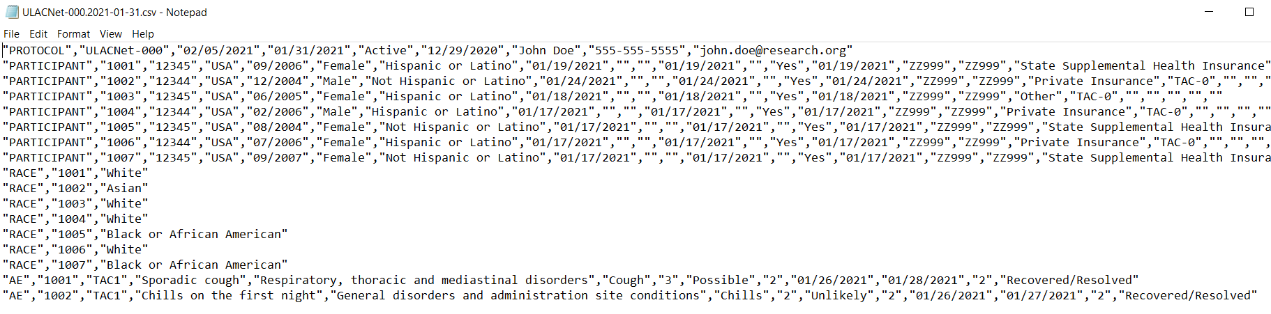

CSV file opened in Excel
Do not double-click a CSV file to view it in Excel because Excel will make assumptions about your data and may format it incorrectly. Instead, you should open Excel, go to the Data tab, and choose “From Text/CSV” to import the file.

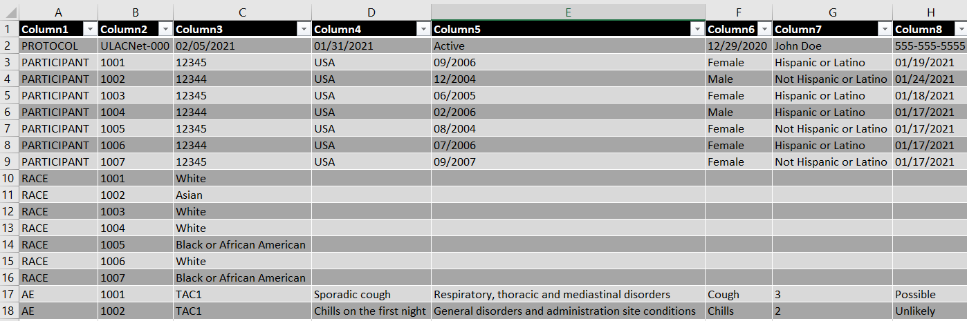

Appendix I - Minimum Data Set Table

Collection Table | Data Element | Definition | Permissible | Data Type | Field Size – max and min, if appropriate | Cancer Data Standards Registry and Repository (caDSR) Public ID
Protocol | DCP Protocol Number | The unique alphanumeric identifier assigned to a protocol by the Division of Cancer Prevention (DCP) |  | Character | 35,1 | 977 v3.0
Protocol | Submission Date | The date on which the report is to be submitted | MM/DD/YYYY | Date | 10
Protocol | Report Cut-off Date | The end date of the reporting interval | MM/DD/YYYY | Date | 10 | 2992 v4.0
Protocol | Current Trial Status | The current status of a clinical study | Active  Administratively Complete  Approved  Closed to Accrual  Closed to Accrual and Intervention  Complete  Temporarily Closed to Accrual  Temporarily Closed to Accrual and Intervention  Withdrawn | Character | 50 | 2518475 v1.0
Protocol | Current Trial Status Date | The date that the current trial status became effective | MM/DD/YYYY | Date | 10 | 2200228 v1.0
Protocol | Name of Person Submitting the Data | The legal name of the person who is submitting the data |  | Character | 87 | 2006163 v1.0
Protocol | Submitter Telephone Number | The telephone number where the person completing/submitting the report can be reached |  | Character | 20,7 | 2200276 v1.0
Protocol | Submitter Email Address | The email where the person completing/submitting the report can be reached |  | Character | 100 | 2200278 v1.0
Participant; Race; AE | Participant Identifier | The unique numeric or alphanumeric identification assigned to a participant in a clinical trial or research study |  | Character | 20 | 2003301 v4.0
Participant | Participant Zip Code | The string of characters used to identify the five-digit zone improvement plan (ZIP) code and the four-digit extension code (if available) that represents the geographic segment that is a subunit of the ZIP code, assigned by the U.S. Postal Service to a geographic location to facilitate mail delivery; or the postal zone specific to the country, other than the U.S., where the mail is delivered |  | Character | 15 | 2179606 v2.0
Participant | Participant Country Code | The code that represents the country where the addressee is located |  | Alphanumeric | 3,3 | 2179605 v1.0
Participant | Participant Birth Date | The month and year on which the person was born | MM/YYYY | Date | 7 | 793 v5.1
Participant | Participant Gender | Text designations that identify gender. Gender is described as the assemblage of properties that distinguish people on the basis of their societal roles [Identification of gender is based upon self-report and may come from a form, questionnaire, interview, etc.] | Female  Male  Unknown  Unspecified | Character | 13,4 | 2200604 v3.0
Participant | Participant Ethnicity | The text for reporting information about ethnicity based on the Office of Management and Budget (OMB) categories | Hispanic or Latino  Not Hispanic or Latino  Unknown  Not Reported | Character | 22,7 | 2192217 v2.0
Participant | Informed Consent Date | The date on which the patient/participant/legal representative agrees OR disagrees to participation in a protocol, treatment, or other activity by signing an informed consent document | MM/DD/YYYY | Date | 10 | 656 v4.0
Participant | Screen 1 Date | Date participant completes Screen 1. This is the step to determine study eligibility for the potential participant. For studies where the intervention is a screening procedure, this is not the date the participant undergoes the first screening procedure. | MM/DD/YYYY | Date | 10 | 2184691 v1.0
Participant | Screen 2 Date | Date participant completes Screen 2. This element is not often used for ULACNet and may be left blank. | MM/DD/YYYY | Date | 10 | 2184691 v1.0
Participant | Registration Date | The date the patient was enrolled on the protocol | MM/DD/YYYY | Date | 10 | 2171 v4.0
Participant | Randomization Date | Date of a process used in therapeutic trials or other research endeavors for allocating experimental subjects, human or animal, between treatment and control groups, or among treatment groups | MM/DD/YYYY | Date | 8,4 | 2182072 v1.0
Participant | Eligibility Status | The yes/no indicator that asks the investigator to stipulate whether the participant is eligible for inclusion on this protocol | Yes  No | Character | 7,2 | 1235 v4.0
Participant | Participant Enrollment Date | The date the participant is accepted into the study. The study site may also be notified to the treatment arm and Study Participant Identifier on this date | MM/DD/YYYY | Date | 10 | 2746541 v1.0
Participant | Registering Consortium | The designation of a consortium that will be officially recorded as the registering consortium for the study |  | Character | 5 | 2813153 v1.0
Participant | Registering Institution | Code that uniquely identifies the institution where the research participant was registered in a clinical trial |  | Character | 10 | 2003307 v4.0
Participant | Participant Method of Payment | Text term for an entity, organization, government, corporation, health plan sponsor, or any other financial agent who pays a healthcare provider for the healthcare service rendered to a person or reimburses the cost of the healthcare service | Private Insurance  Medicaid  Medicaid and Medicare  Military Sponsored (including CHAMPUS & TriCare)  Veterans Sponsored  No Means of Payment (No Insurance)  Medicare  Medicare and Private Insurance  Self-Pay (No Insurance)  Managed Care/Medicare  State Supplemental Health Insurance  Military or Veterans Sponsored, NOS  Other  Unknown | Character | 50 | 2865130 v1.0
Participant, AE | Treatment Assignment Code (TAC) | A coded value representing a treatment assigned to be uniformly administered to a group of study subjects for separate statistical analysis |  | Character | 10,1 | 1967 v4.0
Participant | Date Agent Started | The start date for the administration of the agent intervention. For screening studies, this is the date the participant undergoes the first screening procedure. | MM/DD/YYYY | Date | 8 | 3028744 v1.0
Participant | Agent End Date | The end date for the administration of the agent intervention. For screening studies, this is the date the participant undergoes the last screening procedure. If there is only one screening procedure, the “Agent End Date” will be the same date as the “Date Agent Started”. | MM/DD/YYYY | Date | 8 | 3028746 v1.0
Participant | Off Study Date | The date when the participant is removed from the protocol, i.e., is not being followed and will not be retreated | MM/DD/YYYY | Date | 8,4 | 2003605 v3.0
Participant | Off Study Reason | Choice of reasons for removing a participant from a clinical trial | Adverse Event  Death  Disease Progression  Lost to follow-up  Other, specify  Participant Withdrawal  Participant Refused Follow-up  Physician Decision  Protocol Defined Follow-up Completed  Protocol Violation  Study Complete  Ineligible | Character | 50 | 2979313 v1.0
Participant | Reason Off Study Other, Specify | The text that describes the reason the participant went off study |  | Character | 200 | 2182613 v1.0
Race | Participant Race | The text for reporting information about race based on the Office of Management and Budget (OMB) categories | American Indian or Alaska Native  Asian  Black or African American  Native Hawaiian or Other Pacific Islander  Not Reported  Unknown  White | Character | 41,5 | 2192199 v1.0
AE | Adverse Event (AE) Verbatim Term | The text that describes the adverse event word for word as described by the participant |  | Alphanumeric | 200 | 2188132 v1.0
AE | MedDRA System Organ Class (SOC) | Text term to represent the highest level of a terminology distinguished by anatomical or physiological system, etiology, or purpose, and referencing an international medical terminology (Medical Dictionary for Regulatory Activities) version 12.0, designed to support the classification, retrieval, presentation, and communication of medical information throughout the medical product regulatory cycle. |  | Character | 80 | 2943864 v1.0
AE | CTCAE Term | Text that represents the Common Terminology Criteria for Adverse Events lowest level term name for an adverse event |  | Character | 84 | 3125302 v1.1
AE | AE Grade | Numeric representation of the intensity/severity of an unfavorable and unintended sign (including an abnormal laboratory finding), symptom, syndrome, or disease, temporally associated with the use of a medical product or procedure, regardless of whether or not it is considered related to the product or procedure (attribution of unrelated, unlikely, possible, probable or definite) | 0 = Absent Adverse Event  1 = Mild Adverse Event  2 = Moderate Adverse Event  3 = Severe Adverse Event  4 = Life-threatening Adverse Event  5 = Death Related to Adverse Event | Character | 1,1 | 2944515 v1.0
AE | AE Attribution | Relation of the causality between the treatment modality and the specific adverse event | Unrelated  Unlikely  Possible  Probable  Definite | Character | 10,1 | 1285 v3.0
AE | Reported as SAE? | The code representing whether the event was reported as a Serious Adverse Event | 1 = Yes  2 = No | Character | 1,1 | 2182930 v1.0
AE | Event Onset Date | The date on which the adverse event was first evident | MM/DD/YYYY | Date | 8,4 | 2744993 v1.0
AE | Event End Date | The last or final date of an adverse event, described using a date or a text response such as Ongoing or Unknown | MM/DD/YYYY | Date | 8 | 2189843 v1.0
AE | Dropped due to AE? | Did the participant stop participation due to AE | 1 = Yes  2 = No | Character | 1 | 2683534 v1.0
AE | Outcome | The final status of the participant related to the adverse event | Recovered/Resolved  Recovering/Resolving  Not Recovered/Not Resolved  Recovered/Resolved with Sequelae  Fatal  Unknown | Character | 33 | 2746517 v1.0

Appendix II - GLOSSARY

AE – Adverse Event
CaDSR - Cancer Data Standards Registry and Repository
CTCAE - Common Terminology Criteria for Adverse Events
DCP – Division of Cancer Prevention
FTP – File Transfer Protocol
IND - Investigational New Drug Application
MDS – Minimum Data Set
NCI – National Cancer Institute
OMB – Office of Management and Budget
PIO – Protocol Information Office
SAE – Serious Adverse Event
SOC - System Organ Class
TAC – Treatment Assignment Code

