SOP 5: Case Report Forms

Overview:
Case Report Forms (CRFs) are customized hard copy or electronic documents used to collect and record the data required to answer the research question(s) for a specific protocol. The System Variable Attribute Report (SVAR) is a customized workbook that may be used in lieu of CRFs to document all questions and data elements required for a specific protocol.
The CRF documents and SVAR are used to collect data in a consistent manner to assure quality, completeness, and accuracy of the final data sets, and to ensure that data collection is done in compliance with Good Clinical Practice, the standards for NCI Common Data Elements (CDEs), and federal regulations including but not limited to 21 CFR Part 11 and the Health Insurance Portability and Accountability Act (HIPAA).

Responsibilities: CRF and SVAR Development
The CLO Investigator, CLO Site Coordinator, or designee will:
  - Develop a CRF set or alternative data collection tool for each new protocol submission that specifies the data to be collected during the study.
    - CRF set: A set of template CRFs for Consortia 2012 studies and Guidelines for use of the templates are posted on the DCP website (see Case Report Forms and SVAR Template under the Conducting tab). These templates may be customized for each protocol, or institutional CRF templates may be used in lieu of the DCP-provided templates to create the CRF set for the protocol.
    - System Variable and Attribute Report (SVAR): A SVAR template, including instructions for use of the SVAR, is posted on the DCP website (see Case Report Forms and SVAR Template under the Conducting tab). The SVAR should be submitted in spreadsheet format. Each tab in the SVAR contains mandatory and study-specific questions, their corresponding attributes (i.e. field length, response value, data type), and the following elements:
      - Change Indicator
      - Question Name
      - Data Type
      - Field Length (including decimal places, if applicable)
      - Field Type
      - Valid Values (value and value meaning)
      - Mandatory?
      - Field Help Text
      - MDS Field?
      - MDS Collection Table
      - Site Comments
      - Curator Comments
      - caDSR Public ID: Version
      - csDSR Definition
15. caDSR Representation (Value Domain Public ID)
  - Confirm that all mandatory or required questions, including those that will be used to collect data for Minimum Data Set (MDS) reporting, are included in the CRF set or SVAR. Mandatory questions are organized by modules (i.e. groups of related CDEs). If a protocol does not use a particular module, the mandatory questions for that module do not need to be included in the protocol CRF set or SVAR. Please see the Minimum Data Set Instructions).
  - Confirm compliance with the standards for NCI’s Common Data Elements (CDEs). Information regarding these standards is available at https://wiki.nci.nih.gov/display/CRF2/CRF+Harmonization+and+Standardization.
  - Determine the versioning practice for any changes to the CRF set. Each CRF or SVAR submission (for each protocol) should be assigned a unique version date. In addition to the version date, a version numbering schema may be used. When version numbers are used, the numbering should be sequential for each subsequent submission of the CRFs or SVAR.
  - Submit the initial and amended CRF set or SVAR and related documents to the DCP Protocol Information Office (PIO) at nci_dcp_pio@mail.nih.gov as part of either a protocol submission, or a submission of a CRF set or SVAR only.. The DCP PIO will then distribute the data collection materials to the designated reviewers, including the DCP CRF/SVAR Review team.
  - Revise the CRF set or SVAR based on comments received from the DCP CRF/SVAR Review Team, as needed, until the CRF set or SVAR is found to be acceptable.
    - The comments from the DCP CRF/SVAR Review Team will be recorded in a Consolidated CRF or SVAR Review Document (Appendix 1A and Appendix 1B, respectively) and/or in the appropriate tab in the SVAR. Each comment on the Consolidated Review Document will be tagged with a comment type to identify the reason the CRF or SVAR revision or clarification is requested (e.g. “MDS Requirement” would be a tag for a comment regarding a missing MDS variable.)
    - For any re-submissions, include a “Response Memo” listing the response to each comment in the Consolidated Review Document and/or SVAR. A clean and tracked copy of the updated CRF set or SVAR must also be submitted.
    - If any changes to the protocol are made during the submission process, review the CRF set or SVAR to determine if parallel changes are needed.
  - Collaborate with the DCP CDE Curator to identify the CDEs for the protocol.
    - If CRFs will be used for data collection, a CDE spreadsheet listing the CDEs approved for the protocol will be distributed to the CLO.
    - Approved CDEs are included in the SVAR for a protocol; however, all CDE comments must be addressed before the SVAR can be finalized and the CDEs released. (See the SVAR Instructions tab).
    - The CDE spreadsheet or SVAR should be used to inform database development for the protocol and will also serve as a description of the expected content of the final dataset for the study.

Responsibilities: Data Management Plan (DMP)
The CLO Investigator, CLO Site Coordinator, or designee will:
- Determine the database of record for each protocol, and the functionality of the electronic CRF set or SVAR
- Confirm the database of record is consistent with the CRF set or SVAR.
- Determine the process of data entry, i.e. de-centralized or centralized. For example, will each enrolling site be responsible for entering their own data into the database (de-centralized), or will this be completed by staff at one central location.
- Determine if the POs will be required to complete a set of paper or electronic CRFs for each participant. This may vary per protocol and may change during the conduct of each study. (For example, PO sites may be asked to complete paper CRFs initially, and then the need for this practice reassessed during the course of the study).
- Confirm that all details regarding data collection, such as the database of record, process for data entry (e.g. centralized or de-centralized) or use of paper and/or electronic CRFs or an SVAR, are specified within the Consortia 2012 CLO’s DMP. If any particular protocol will diverge from the CLO’s designated standard of data collection, the data collection method should be added as an appendix to the CLO DMP.

Responsibilities: Communication
The CLO Investigator, CLO Site Coordinator, or designee will:
- Communicate the protocol-specific data collection practices to each PO and/or enrolling site.
- Ensure each enrolling site is using the most current version of the CRF set or SVAR throughout the conduct of the study.
- Ensure that each enrolling site follows all determinations by the CLO as to the use and versioning of CRFs or SVAR.

Documentation Requirements:
Each CLO is responsible for maintaining the following documentation:
- Current Consortia 2012 CLO DMP and any related appendices that reflects the current data collection practices for each protocol.
- The letter of acceptance from DCP regarding the CRF set or SVAR for each protocol.
- The CDE spreadsheet listing all approved CDEs for each protocol when data will be collected using CRFs. CDEs are included in the SVAR for each protocol.

Additional Information:
Refer to the DCP Acronym List to see the description for commonly used acronyms in this SOP.

Please send questions and comments to the DCP Help Desk at:
1-844-901-4357 or dcphelpdesk@dcpais.com

Appendix 1A - Consolidated CRF Review Document
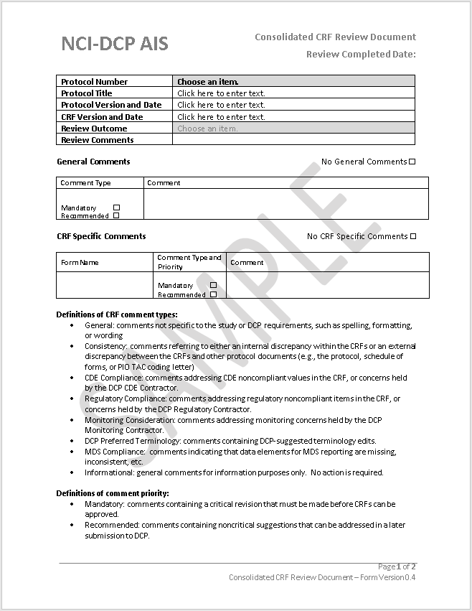

Appendix 1B - Consolidated SVAR Review Document

