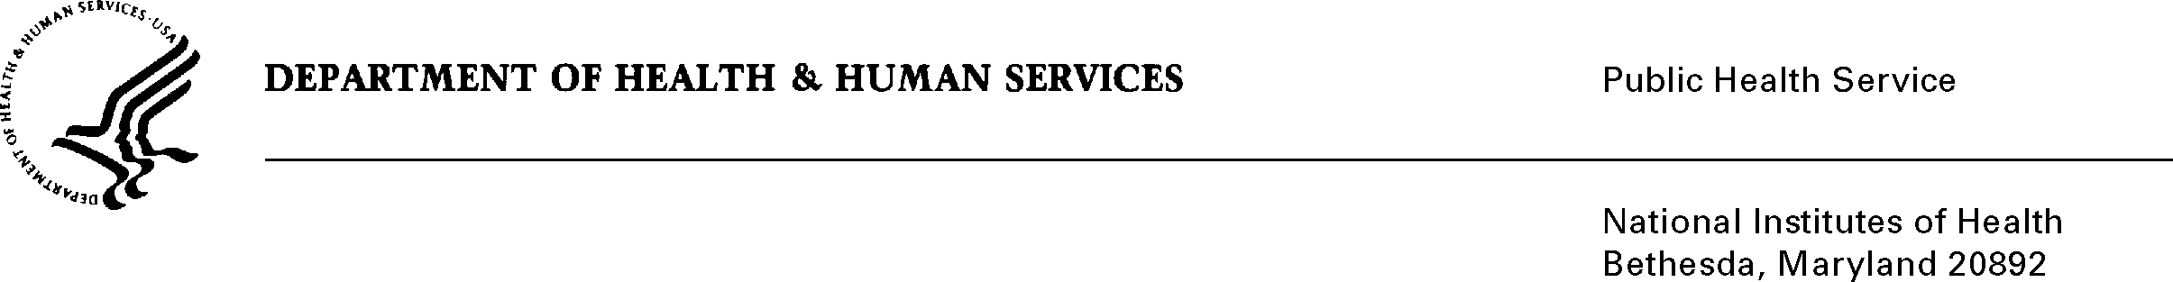
December 18, 2017

Dear Investigator:

The National Cancer Institute Division of Cancer Prevention (DCP) Consortia Informed Consent Document (ICD) Template for use in NCI-supported clinical trials has been revised:

- To comply with upcoming OHRP Common Rule requirements, there is a new “Overview and Key Information” section at the beginning of the ICD and consent language added to deal with the use of biospecimens, disclosure of individual research results and whole genome sequencing.

- To describe the implications of genomic testing, increasingly used in clinical trials for determining study eligibility and assignment to study groups.

- To clarify the “exams, tests, procedures” and “costs” sections, particularly to further delineate routine, clinically indicated tests and procedures versus those done for research purposes.

- To improve the readability of the entire template. With the aid of plain language experts, we have ensured that revisions adhere to plain-language principles while retaining the conciseness that was the central rationale behind the previous template revision in 2013.

- Moreover, you will notice that the template contains several formatting changes, which we hope will further improve readability, both for trial participants and ICD authors. For ICD authors, we have added a Table of Contents.

- To offer additional examples of schemas for trials with screening steps and multiple treatment steps, acknowledging the increase in the number of such trials.

- Note on Certificate of Confidentiality Issues: Beginning with the December 12, 2017 version of this template, the new Certificate of Confidentiality protections covering all NIH-funded research are addressed in the first paragraph under the section, “Who will see my medical information?” Please note that currently NCI CIRB approved consent forms do not need to have this addition, but this paragraph should be used in all consent forms being updated with amendments.

- Updated risk added in the section: “What risks can I expect from taking part in this study? Many cancer clinical trials require pathology specimens be submitted as part of the clinical trial and additional blocks and/or slides are requested for correlative science studies embedded in the trial. This new language should be used in clinical trials where there is concern that patient tissue may all be utilized for research and may not be available for possible future clinical use.

The revision process has encompassed the input of a variety of perspectives and disciplines, including many patient advocates; experts in oncology, genetics, regulatory issues, bioethics, and insurance coverage and clinical trialists who work with ICDs, including trial operational staff, trial site leaders and health care providers.

The new, December 14, 2017 version of the DCP Consortia ICD Template is now posted on the DCP website at https://prevention.cancer.gov/clinical-trials/clinical-trials-management/protocol-information-office/pio-instructions-and-tools/2012-consortia. Additionally, this webpage has a link to the CTEP website which contains several other ICD-related resources, such as instructions for using readability tools, concise tables of side effects for commercial anti-cancer drugs and regimens for inclusion in ICDs, and instructions on how to build such tables.

The Final Rule to revise the current regulations at 45CFR 46, Subpart A (Common Rule) was published on January 19, 2017 in the Federal Register. Thus, please use this new version of the Template for new protocol submissions to NCI as soon as possible. Officially however, the revisions to the NCI Informed Consent Template will become effective January 19, 2018. Consents that were IRB reviewed and approved before January 19, 2018 are considered “grandfathered”, which means they will not be required to comply with the recent changes in the final rule.

We would like to emphasize that the DCP ICD Template is a “living document” – it will continue to be revised over the years as new needs arise and science changes.

We would like to thank all of you who sent us valuable comments on the template. You have played an important role in its improvement, and we hope these revisions will help facilitate the decision-making process for potential study participants regarding participation in a clinical trial.

Sincerely,

Eva Szabo, M.D.
Chief
Lung & Upper Aerodigestive Cancer Research Group
Division of Cancer Prevention, NCI, NIH

